HRSA Partnership Directory
Our HRSA Partnership Directory provides a list of organizations who have been identified as powerful allies throughout our journey on the C5: Changing Communities through Compassionate Counseling Children & Youth.
We encourage you to reach out to these organizations directly or contact our team who can assist in connecting you with the appropriate party.

Directory
Charles Evans Center | https://charlesevanscenter.org/ | 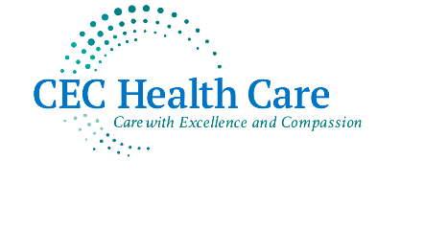
Long Beach Reach | https://longislandreach.org/ | 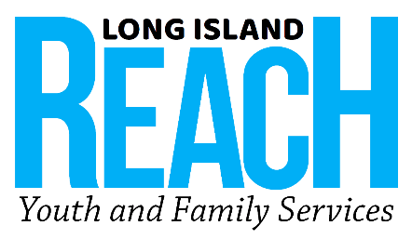
WellLife Network | https://www.welllifenetwork.org/
SCO Family of Services | https://sco.org | 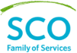
Northwell Health | https://www.northwell.edu/
Freeport Public School District | https://www.freeportschools.org/ | 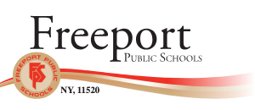
Seafield Center Inc. | https://www.seafieldcenter.com/
Acacia Network | https://acacianetwork.org/ | 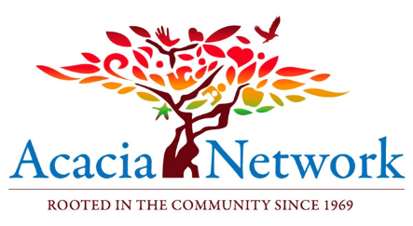
Gotham Health | https://www.nychealthandhospitals.org/gotham-health/ | 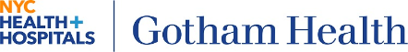
Urban Light Mental Health | https://urbanlightmentalhealth.com/ | 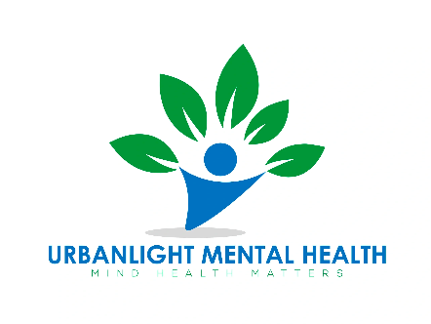
Family & Children’s Association | https://www.fcali.org/ | 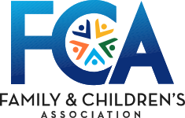
Family Residences and Essential Enterprises, Inc. | https://www.familyres.org | 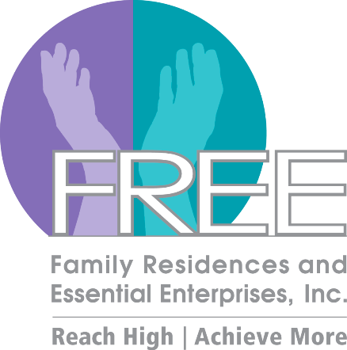
Harmony Healthcare Long Island | https://www.harmonyhealthcareli.org/ | 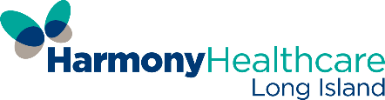
Hicksville School District/ Community | https://www.hicksvillepublicschools.org/ | 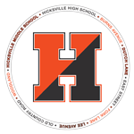
EPIC Long Island | https://www.epicli.org/ | 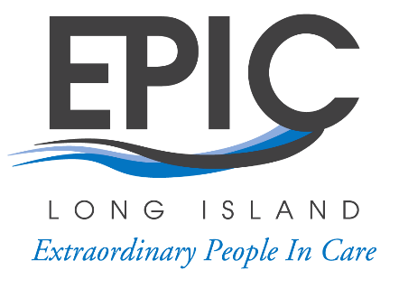
Long Island Council Alcohol & Drug Dependence | https://licadd.org/ | 